LEG

# Objective:

The Smith & Nephew’s LEG developed using VBA customizations need to be converted to .NET framework in compatible with AutoCAD 2018, adhering to best practices, supporting 64 bit architectures.

# Overview:

This document gives an outline of input details need to generate required output, working flow and output details of LEG module in Smith & Nephew project.

# Description:

# Scope:

* LEG module is used to draw Left and Right Leg in the standard template drawing “SN.dwt” using the details from “MAINPATIENTDETAILS” block reference.
* For LEG module, first we need to update the attributes of “MAINPATIENTDETAILS” block reference using NEWPATIENT command. Without that, we can’t run LEG module.

# Technology:

We are using VB.net technology and AutoCAD 2018 for LEG.

# Deliverable:

AutoCAD 2018 customized plug-in DLL.

# Steps to Run:

1. Open AutoCAD 2018 and open a drawing using “SN.dwt” template file.
2. Run NETLOAD command in Command prompt.
3. Load the updated “SmithNephew.dll” file in AutoCAD.
4. Run NEWPATIENT command in Command Prompt and update the attribute values in “MAINPATIENTDETAILS” block reference.
5. Run LEG command in Command Prompt.
6. “Leg” dialog will be opened.
7. In that dialog, Enter the required details for Left or Right Leg.
8. After entering details, click draw button.
9. Now, the corresponding Left or Right Leg will be drawn successfully.

# Dialog Design:

# Left LEG:

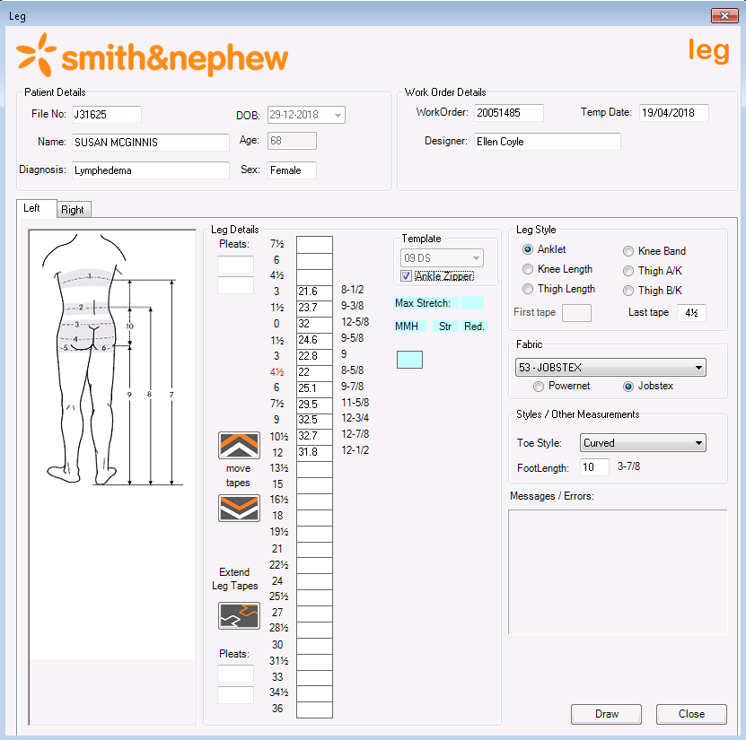

# Right LEG:

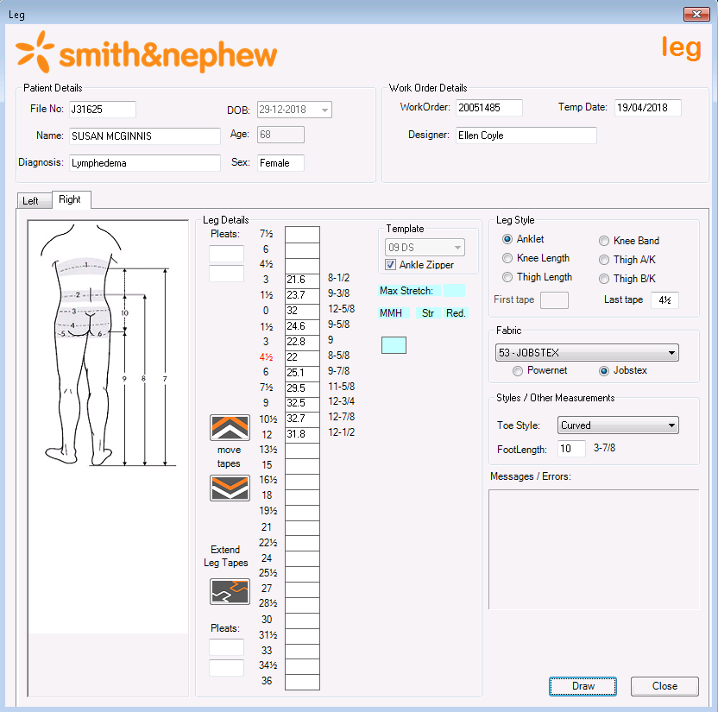

# Required Output:

# Left LEG:

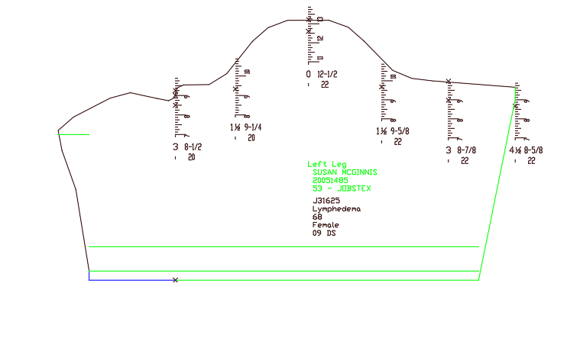

# Right LEG:

